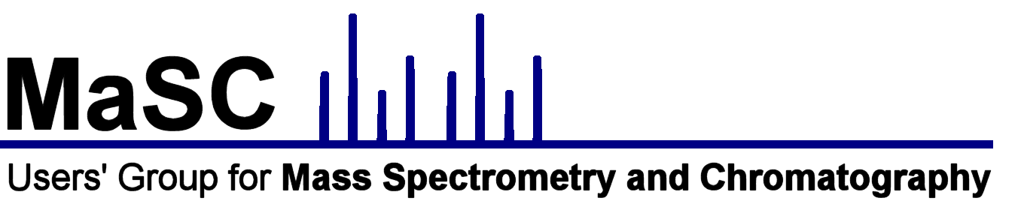

Registration form

8th MaSC Workshop and Meeting
26–30 September 2017, Évora, Portugal

1. Personal details:

Title:

Name:

Institution/affiliation:

Position:

Address:

Phone:

Fax:

E-mail:

If you do NOT wish for these details to be included in the book of abstracts please tick this box

2. I would like to participate in:

COMPLETE WORKSHOP - 26, 27 & 30 September 2017

AMDIS & ESCAPE WORKSHOP - 30 September 2017

MEETING - 28-29 September 2017

3. Complete Workshop, 26–27 and 30 September 2017
HERCULES Lab, University of Évora

The workshop is limited to 12 participants. If you wish to participate please submit a short paragraph before 30th of June describing your experience with gas chromatography / mass spectrometry and how you would benefit from the workshop; notification of acceptance will be communicated by 17 July 2017.

4. AMDIS and ESCAPE Workshop 30 September 2017
HERCULES Lab, University of Évora

The morning session, which will describe the use of AMDIS for interpreting GCMS data, is open to all. If you wish to participate in the afternoon session, which will describe the use of the ESCAPE method for interpreting GCMS data, you must have at least one year of experience using GCMS methods for analysis of cultural heritage materials. Please submit a short paragraph before 1 July describing your experience with gas chromatography / mass spectrometry and how you would benefit from the workshop; notification of acceptance will be communicated by 15 July 2017. NOTE: Participants must bring a laptop capable of running on battery alone for three hours and have AMDIS and Microsoft Excel loaded and operational before the workshop. Participants will be required to work in pairs on the same laptop.

AMDIS was developed at NIST as an Automated Mass spectral Deconvolution and Identification System. For more information and to download the free version of the software, please visit http://chemdata.nist.gov/dokuwiki/doku.php?id=chemdata:amdis

Although the ESCAPE method was developed at the Getty Conservation Institute specifically for their project http://www.getty.edu/conservation/our_projects/education/radical/index.html, it has much wider utility for all cultural heritage materials amenable to GCMS analysis.

I have a laptop with both AMDIS and Microsoft Excel and will share with someone.

I have a laptop with both AMDIS and Microsoft Excel and will be sharing with:
I do not have a laptop and understand unless I can share with someone, I will not be able to participate

I do not have a laptop and will be sharing with:
5. Meeting, 28–29 September 2017
HERCULES Lab, University of Évora

Those interested in presenting a paper or poster should submit an abstract to masc@uevora.pt before 30th June 2017. Please use the abstract template.
Indicate here if your submission is for an oral or poster presentation:

Oral Presentation

Poster Presentation

6. Payment

Details of methods of payment will be provided once registration is complete

Fees:
Workshop EUR 350
Meeting, registration before 18 August 2017 EUR 150
Meeting, registration after 18 August 2017 EUR 200
Meeting, student registration EUR 75

7. Deadlines

Expression of interest in workshop 30 June 2017
Submission of abstract for meeting 30 June 2017
Early registration for meeting (EUR 150 reduced fee) 18 August 2017
Payment ends 7 September 2017

Please send completed form to masc@uevora.pt

